Unit 2.2 Introduction: Density
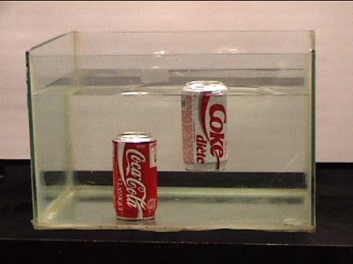
Here's an easy science experiment to do at home. Take a can of regular soda and a can of diet soda and put them into a container of water. Most likely the regular soda will sink, and the diet soda will float. Why? The answer is density.
Coke vs. Diet Coke Experiment.

What is density? Density is simply the amount of "stuff" in a given space. Scientists measure density by dividing the mass of something by its volume (d = m/v). The volumes of both cans of soda are the same. To find the mass of the sodas, you would have to use a scale. When you mass each of the cans of soda, you would find that they are different. Even though both cans are exactly the same size and shape and have exactly the same volume of soda (twelve fluid ounces), the masses are different. This is because the can of regular soda has more density due to the sugar dissolved in the soda. It will be heavier than the diet soda, and that is why it will sink.
Density is an important physical property of matter that describes how closely the atoms of a substance are packed together. The more closely packed the atoms, the more density the substance has. Since different substances have different densities, scientists can measure the density of a substance to identify the substance. They can also use the measure of density to find out if the substance will sink or float.
Density is actually a ratio of a substance's mass to its volume. Mass is the amount of matter contained in a substance and is commonly measured in units called grams (g). Volume is the amount of space that the substance takes up, and it is commonly measured in either cubic centimeters or in milliliters. One cubic centimeter is equal to one milliliter. Since density is a ratio of mass to volume, density is written as grams per cubic centimeter (g/cm³) or grams per milliliters (g/ml).
Each substance has its own density based upon the amount of its mass per volume. Water has a density of one. Liquids and solids with a density greater than one will sink. If the density of an object is less than one, then the object will float. Let's look at an example. A rock might have a mass of 2,268 g and occupy a volume of 1,230 cm3. The density of the rock is:
2,268 g/1,230 cm³ = 1.84 g/cm³
Since we calculated the density to be greater than one, we know that this rock would sink if placed in water.
Have you ever noticed what happens to a bottle of oil and vinegar salad dressing after it has been shaken? The shaking causes it to mix, but if it sits for a while, the oil will rise to the top and the vinegar will settle to the bottom of the bottle. This happens because oil is less dense than vinegar.
Density also explains why ice floats. Ice is just frozen water, right? So why does ice float in water? When we find the mass of an ice cube and divide that by its volume, we come up with about .92. Ninety-two hundredths is less than one, so the density of ice is less than that of water. Ice floats because the ratio of its mass to volume is less than one.
A glacier floating in water.

Reading Comprehension Questions
 |  | 1. What is density? The amount of "stuff" in a given space A ratio of a substance's mass to its volume Density = mass/volume All of the above |  | 2. Density is what kind of property? Physical property Chemical property Atomic property
 |  | 3. What does density have to do with atoms? Density describes how many atoms are in a substance. Density describes how closely the atoms of a substance are packed together. Density describes how atoms float. |  | 4. All substances have the same density. False True
 |  | 5. Scientists can use the measure of density to tell if something will float. False True |  | 6. What is mass? The amount of space something takes up. The amount of matter in a substance Measured in grams or kilograms Both B and C
 | 7. What is volume? The amount of space something takes up. The amount of matter in a substance Measured in cubic centimeter or milliliters Both A and C |  |  | 8. What is the density of water? 2,268 1 .92 1.84

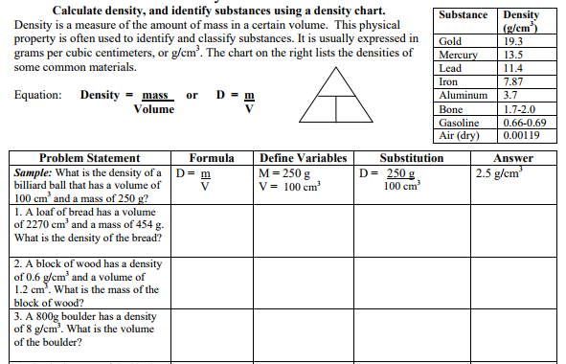

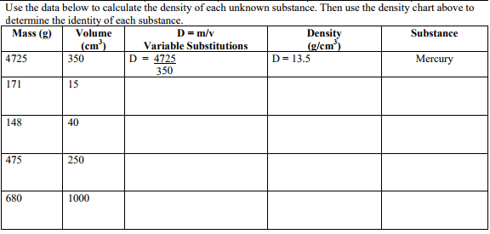

Write a song that explains the difference between the different quantities we will be studying this unit: weight, mass, volume, and density. Please include the tune to which the lyrics should be sung!
(Ex. Den-si-ty is mass over volume, mass over volume.
Gra-vi-ty determines the weight, determines the weight
Sung to: Stayin’ Alive)
Have fun Believe it or not, this will help you remember these terms!

